Lab 2
Objectives:
The objective of this experiment is to generate a Poisson distribution for a single-pump service station where cars arrive for fueling. Given that vehicle arrivals follow a Poisson process with an average rate of λ = 12 cars per hour, the program calculates the probability of observing x = 0 to 15 arrivals in an hour. Using the Poisson probability mass function, the program computes and displays the likelihood of each occurrence. This experiment helps in understanding queueing theory and probability modeling in real-world service systems.

Q.1. In a single pump service station, vehicles arrive for fueling with an average of 5 minutes between arrivals. If an hour is taken as unit of time, cars arrive according to Poison’s process with an average of λ=12 cars/hr. Write a C program to generate Poisson distribution for x = 0,1,2, …. 15.
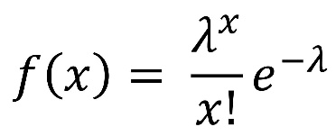
Source Code:
#include <stdio.h>
#include <math.h>
#include <stdlib.h>
double poisson(int x, double lambda) {
return exp(-lambda) * pow(lambda, x) / tgamma(x + 1);
}
int main() {
double lambda;
// Prompt user for input
printf("Enter the average arrival rate (lambda): ");
if (scanf("%lf", &lambda) != 1 || lambda <= 0) {
printf("Invalid input. Lambda must be a positive number.\n");
return 1;
}
printf("\nPoisson Distribution for x = 0 to 15:\n", lambda);
printf("-------------------------------------------------\n");
for (int x = 0; x <= 15; x++) {
double probability = poisson(x, lambda);
printf("P(X = %2d) = %.6f\n", x, probability);
}
return 0;
}
Output:
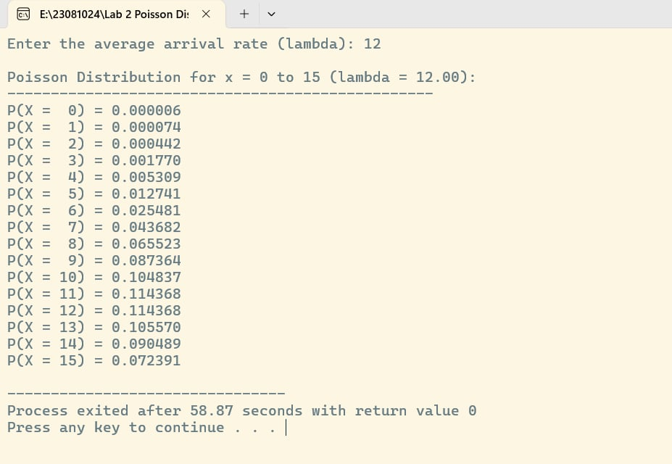

Conclusion:
The experiment successfully demonstrated the application of the Poisson distribution in modeling vehicle arrivals at a single-pump service station. The results showed that as the number of arrivals (x) increases, the probability of occurrence first rises and then gradually decreases, aligning with the expected behavior of a Poisson process. This validates that the Poisson distribution is an effective tool for predicting random arrival patterns in service systems. Understanding such distributions is crucial for optimizing resource allocation, reducing wait times, and improving service efficiency in real-world applications.

